**SOFTENG 350**

**Tutorial 2: Heuristic Evaluation**

**Worth 1% of your final grade**

**Tutorial exercises should be undertaken in pairs**

**Fill out your responses in this worksheet, in your own words**

**You should plan to spend 40 minutes on this tutorial**

**Upload your completed worksheet to Canvas**

**Due in your tutorial, or by 6pm on Friday 20 March**

**Aims**

The aim of this tutorial is to give you experience in undertaking a heuristic evaluation for a software system. You will practice this skill in Assignment 1.

**Background**

Your task is to do a heuristic evaluation in order to evaluate the usability of the *Book A PC* service at the university (<https://bookpc.ic.auckland.ac.nz/>).

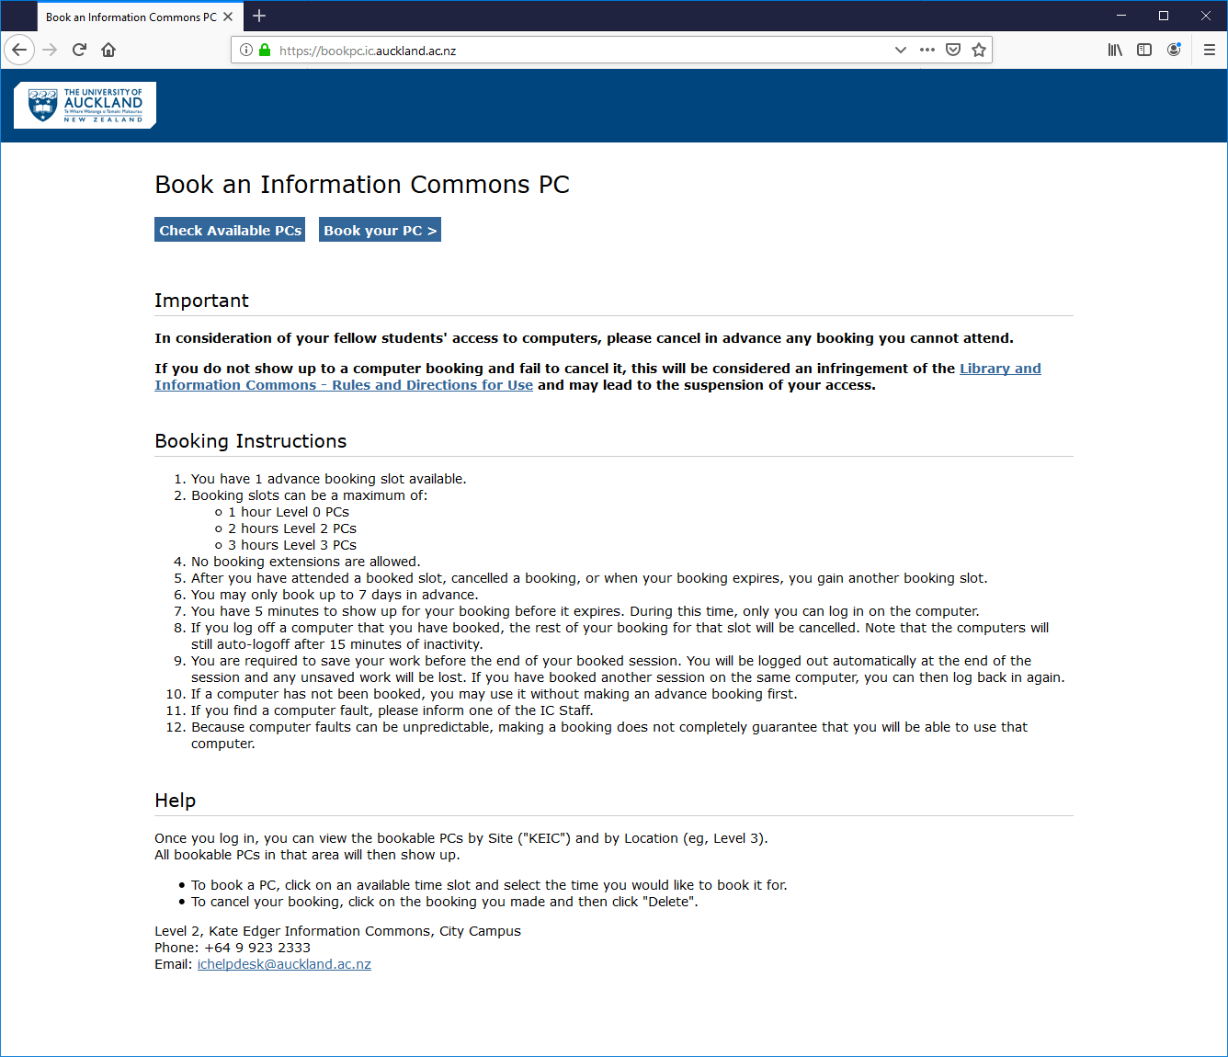

We will follow the heuristic evaluation approach described in lectures and from the reading of Chapter 25.5.

**Activity 1**

As a pair, step through each of Nielsen’s 10 heuristics and evaluate the Book a PC service in regards to that heuristic. For each issue you identify create a new row under the heuristic that you are currently evaluating to document the issue. For the criticality section you can classify the issue as High/Medium/Low to indicate how much attention you think the issue deserves. Try to identify a change to the website that would fix each of the issues that you identify.

|  |  |  |  |
| --- | --- | --- | --- |
| **Usability issue** | **Criticality** | **Place/page** | **Suggested solution** |
| *1. Visibility of System Status* | | | |
| _default has no inherent meaning for the user. | Medium | MyPC page | Use the name of the location instead |
|  |  |  |  |
| *2. Match between System and the Real World* | | | |
| Names of the computers do not match with how a person would find the computer in the real world. | Medium |  | User can pick a computer on a map instead |
| *3. User Control and Freedom* | | | |
| No breadcrumbs to go back to where the user came from when clicking ‘Book your PC’ | Medium | ‘Book an Information Commons PC’ page | Add breadcrumbs at the top to go back to original page. |
| *4. Consistency and Standards* | | | |
| Pages do not have consistent styling. | Low | Throughout the process | Use consistent styling/components |
| *5. Error Prevention* | | | |
| Clicking the fullscreen button and changing vertical zoom to 3 breaks the application. | High | MyPC home page | Fix this bug |
| *6. Recognition Rather Than Recall* | | | |
| Home page for MyPC booking has too much information. | Medium | MyPC home page | Have a cleaner process for booking a computer, using more bite-sized steps. |
| *7. Flexibility and Efficiency of Use* | | | |
| Updating language does not change the language on the page until refreshed.  ` | Medium | ‘User information’ page | Refresh the page after updating language |
| *8. Aesthetic and Minimalist Design* | | | |
| Too much whitespace to the left of the computer ids. | Low | MyPC home page | Dynamically change the column width depending on the length of the header. |
| *9. Help Users to Recognise, Diagnose, and Recover from Errors* | | | |
| Booking a room under site: ‘_default’ and clicking save returns an error. | Medium |  | Don’t allow clicking when computer is not available |
| *10. Help and Documentation* | | | |
| Help button does not do anything. | High | ‘User information’ page | Develop a page with common information/guide to using the site |
|  |  |  |  |

When describing each usability issue, we recommend including partial / cropped screenshots to highlight the issues that you’ve identified.

**Tutorial 2 Worksheet Rubric**

*Criteria*

* Application of concepts: Correct interpretations of heuristics.
* Quality of identified issues: Identified a relevant set of issues that represent real issues and cover an appropriate scope of the site. Criticality is appropriately justified.
* Quality of solutions: Appropriate, relevant and thoughtful suggestions for improvement.
* Overall quality: Clarity of writing / descriptions / use of annotated screenshots and professionalism of the presentation

*Assessment of criteria*

Criteria are assessed as excellent, good, satisfactory, unsatisfactory or fail. A letter grade is assigned based on holistic assessment of the categories.